**ST. MARK UNITED METHODIST CHURCH**

Reverend Mike Bruce

Worship Service 10:30 am August 24, 2025

***11th Sunday After Pentecost***

**PRELUDE**  “Blessings to You” *Bob Mays*

**WORDS OF WELCOME**

**\*CALL TO WORSHIP**

L: The Lord is our rock and refuge.

**P: God is our fortress in times of trouble.**

L: The Holy saves us from the hand of the wicked.

**P: God delivers from our foes.**

L: Christ heals us from our infirmities.

**P: The Spirit frees us from the chains that bind us.**

L: Rest in the Source of our refuge and our strength.

**\*OPENING PRAYER**

Great Healer, we are beaten down by life’s suffering. Make us whole, O God, and help

us share your healing with the world. Free us from the demons that shackle our spirits, and set

us free from the chains that bind us, that we may help break the chains of others. We worship

and pray in the name of Jesus. Amen.

**\*HYMN OF PRAISE** “Glorious Things of Thee Are Spoken” **UMH 731**

**\*NICENE CREED** **UMH 880**

**\*GLORIA PATRI UMH 70**

**CHILDREN’S MOMENT**

**PSALTER** Psalm 71: 1-12 **UMH 794**

**JOYS AND CONCERNS**

**PASTORAL PRAYER**

**THE LORD’S PRAYER UMH 895**

**ANTHEM** “Amazing Grace/My Chains are Gone” *by Tomlin**Chancel Choir*

**TITHES & OFFERINGS**

**OFFERTORY** “It’s My Honor” *Bob Mays*

**\*DOXOLOGY UMH 95**

**\*PRAYER OF DEDICATION**

**\*HYMN OF PREPARATION** “God of Love and God of Power” **UMH 578**

**SCRIPTURE LESSON Jeremiah 1: 4-10**

**SERMON** CALLED, ONE AND ALL *Rev. Mike Bruce*

**\*HYMN OF RESPONS****E** “When Jesus the Healer Passed Through Galilee” **UMH 263**

**\*BENEDICTION**

**\*BENEDICTION RESPONSE** “My Life is in You, Lord” *Chancel Choir*

**\*POSTLUDE**  “Come, We That Love the Lord” *Chuck Long*

*\*Please stand (if able)*

***\*A special Thank You to Bob Mays for sharing two original Christian songs with us during the service.\****

**ANNOUNCEMENTS**

FLOWERS were given by Marylin Shaw and Renee Wilcox in Memory of their loved ones.



*FLOWER CALENDAR – The flower calendar is located on a display board directly to your right as  
you enter the Narthex doors. Flowers may be placed for special occasions, in honor of, or in memory of loved ones. If you have questions regarding the placement of flowers, please contact the church office. As a reminder, flowers are at a cost of $43.60 per vase. There are typically two vases, and you may choose to share a Sunday with someone else.*

**CHURCH STAFF**

**Rev. Mike Bruce –** Pastor

**Email:** [revmbruce@gmail.com](mailto:revmbruce@gmail.com)

**Phone:** (843) 206-5283

**Barbara Vena –** Music Director

**Email:** [bavena@gmail.com](mailto:bavena@gmail.com)

**Phone:** (609) 709-6027

**Jamie Ackerman** – Church Admin

**Email:** [stmarkumcsec@gmail.com](mailto:stmarkumcsec@gmail.com)

**Phone:** (843) 766-5239

**Stacey Shealy –** St. Mark Day School Director

**Email:** [staceyshealy@gmail.com](mailto:staceyshealy@gmail.com)

**Phone:** (843) 343-4457

**2025 LEADERSHIP POSITIONS**

**Betsy Petit** – Church Council Chairperson

**Mark Seel** – Trustee Chairperson

**Kenny Barfield** – Trustee Vice-Chairperson

**Vicki Davidson** – SPPRC Chairperson

**Dawn Ackerman** – Finance Chairperson

**Elaine Gooch** – Church Treasurer

**The Homecoming Committee is looking for photos of St. Mark events from the last 5 years. If you have any to share, please bring them to the church office or give them to Patty Barfield. If you need them back, please indicate that on the back of the prints.**

*(A complete listing of 2025 Leadership Positions is available on the table in the Narthex)*

**ST. MARK UNITED METHODIST CHURCH**

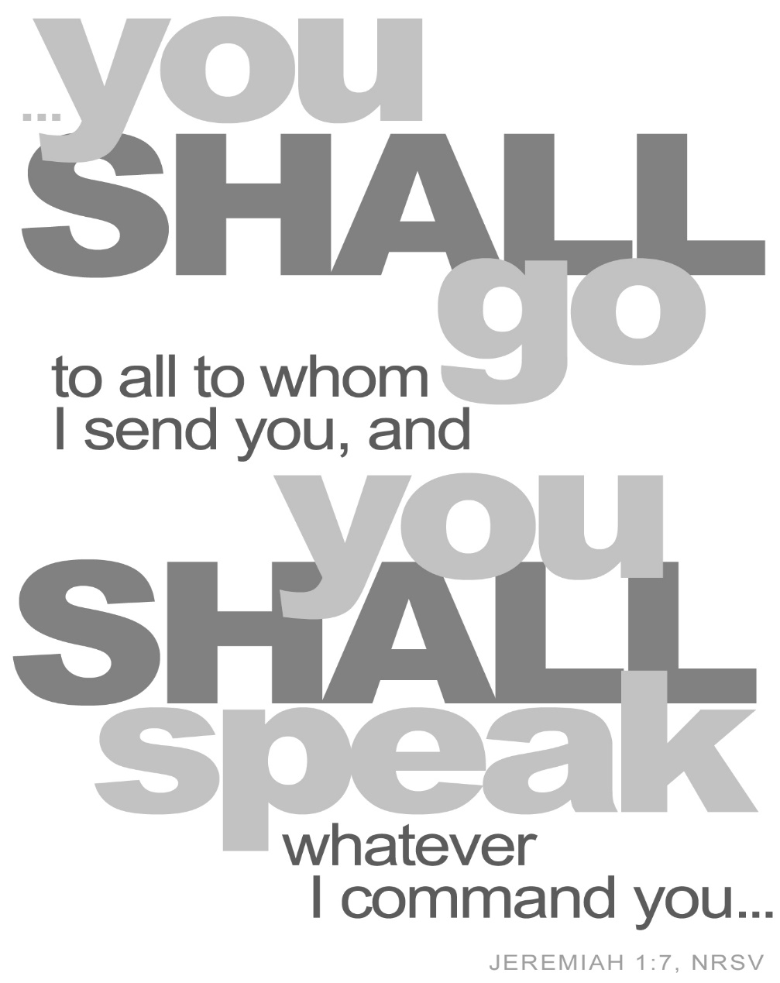

413 Geddes Avenue

Charleston, SC 29407

**Phone:** (843) 766-5239

**Email:** [stmarkumcsec@gmail.com](mailto:stmarkumcsec@gmail.com)

**Church Office Hours:** Monday – Thursday

8:30 am – 1:30 pm

**ANNOUNCEMENTS cont.’**

**Third Grade Bibles**

It is the tradition of St. Mark UMC to give third graders a Bible. We will be giving these on September 21 during worship service. If you have a third grader or an older child who has not received a Bible from us, please call the church office so that we can plan to present one on September 21.

**WEEKLY CALENDAR**

**Sunday, August 24th**

9:30 am Adult Sunday School

10:30 am Worship Service

10:45 am Children’s Sunday School

**Monday, August 25th**

All Day Teachers Return to Day School

**Wednesday, August 27th**

6:00 pm Chancel Choir Rehearsal

7:30 pm Anita Carpenter Memorial Handbell Choir Rehearsal

**Thursday, August 28th**

6:00 pm Move Furniture in Narthex/Social Hall

**Friday, August 29th**

9:00 am Stripping and Waxing Floors (Social Hall and Narthex will be closed)

**BIRTHDAYS:** Evan P. McMillan (8/26), Suzanne Davis Motley (8/27), Bobby Scaffe (8/28).

**OUR PRESENCE…**

Service Attendance Last Week: 68

Service Attendance Online Last Week: 6

Service Attendance Total: 74

**OUR PRAYERS:** Libby Massalon, Evan McMillan & Family, Bridget Legare, Barbara Shaw, Joyce Aldridge – prayers for blessings and guidance, especially in the upcoming months, Micheal Moskos – comfort and healing from a traumatic cycling accident, Barbara Ropp passed away – prayers for family during this time of mourning, Ann Magwood – prayers for understanding, comfort, and healing with a terrible cancer diagnosis, Cayden Axman – prayers for healing, Barbara Chandler’s brother, Al.

**OUR GIFTS…**

Needed Each Week for Budget: $4,285

Received Last Week for Budget: $4,072

Received Online for Budget: $335

Total Received for Budget: $4,407

YTD Receipts through July: $129,006

YTD Expenses through July: $127,861

**TEXT GIVING** -- to give via text, send SaintMarkUMC to 73256. You will receive a text message in response with your next steps. You may also scan the QR code to give online.

**OUR SERVICE...**

**NURSERY VOLUNTEERS ACOLYTES**

August 24th Jamie AckermanAugust 24th Henry Seel

August 31st *Uknown* August 31st Alex Slater

September 7th *Uknown* September 7th *Uknown*

***\*We ask if you are a volunteer, please arrive 15 minutes early to prepare for your duties.\****

**\*NURSERY COVERAGE, August and September 2025.**

We need volunteers to sign up for the nursery! If you have completed your Safe Sanctuaries Training and submitted your background check to the church office, we ask that you please help us by choosing a date to care for our littlest ones on Sunday during worship service. If you have any questions or concerns or you need to make a change to the date you have already selected, please contact Jamie in the Church Office at any time. Thank you.

**\*NO 5th SUNDAY DINNER IN AUGUST\***

There will be no 5th Sunday Dinner this month due to the 70th Anniversary being just two weeks later. Please ensure that you mark your calendars for this cancellation. If you have any questions, please reach out to Rhonda Cummings or the church office.

**ST MARK UMC DAY SCHOOL AMAZON WISH LIST FOR 2025-2026**

It is time again for the school year to begin, and teachers are preparing their rooms for the new curriculum this year. We have sent out the teachers' combined Wishlist via MailChimp, and we ask that, when time permits, if you could be so kind as to review the list to see if there is anything that you can provide, the Day School would be greatly appreciative of it. If you have any questions regarding the list or would like to donate without having to purchase any one thing specifically, we ask that you reach out directly to Stacey Shealy. [Day School Wishlist](https://www.amazon.com/hz/wishlist/ls/30XLHLRAWRX5S?ref_=wl_share&fbclid=IwY2xjawL4kHtleHRuA2FlbQIxMQABHoC8bB7u2suTwNvx32KrUYemWQRVm8H5ukr5JUNISWteELMKbC4XnCSFQ38W_aem_M1EBoHUaXXjO83UrOz1GmQ)

**SAVE THE DATE, ST MARK UMC 70th ANNIVERSARY, Sunday, September 14th**

Please reserve Sunday, September 14th to help celebrate St. Mark’s 70th anniversary! We ask that if you have any friends or if you know of any previous members that you still have contact info for, that you will kindly invite them to join us. Let’s work together to make this such a wonderful Anniversary for our beautiful church.

**EPWORTH IS OUR MINISTRY!**

Because of our support last year Epworth served 1,677 children and families through its statewide programs. On Sunday, September 7th, 2025, we will participate in the annual Work Day Offering to benefit the children who call Epworth home, as well as each child and family touched by Epworth’s ministries. Please be in prayerful consideration of what God is calling you to give to help Epworth make a difference in the lives of children and families every day. For more information about Epworth, visit online at www.epworthsc.org.