ST. MARK UNITED METHODIST CHURCH
Reverend Mike Bruce
Worship Service 10:30 am November 30, 2025

1st Sunday of Advent

PRELUDE “Veni Emmanual” by Sharon Rogers

WORDS OF WELCOME

*CALL TO WORSHIP

L: What time is it?
P: This is God’s time!
L: What time is it?
P: It is a time for peace.
L: What time is it?
P: It is a time to get ready.
L: What time is it?
P: It is time to worship and sing praise!

*OPENING PRAYER
Everlasting God, we begin our journey toward Christmas with hope stirring within.
Teach us how to get ready. Show us how to prepare our hearts for Jesus. Help us walk in your
ways, as we put on your Son, Jesus Christ. Guide us on your paths of peace and understanding
as we prepare our hearts anew for the road ahead. We prepare and worship in the name of
Jesus. Amen.

*HYMN OF PRAISE “Come, Thou Long-Expected Jesus” UMH 196

THE LIGHTINNG OF THE ADVENT WREATH THE ACKERMAN FAMILY
We light this candle as a symbol of Christ our Hope. May the light sent from God shine in the darkness to show us the way of salvation. O Come, O come, Emmanuel.

*NICENE CREED UMH 880

*GLORIA PATRI UMH 70

CHILDREN’S MOMENT Rhonda Cummings

*PSALTER Psalm 122 UMH 845

JOYS AND CONCERNS

PASTORAL PRAYER
THE LORD’S PRAYER UMH 895

ANTHEM “Voice in the Wilderness” Chancel Choir
Pepper Choplin
TITHES & OFFERINGS

OFFERTORY “Samuel Tells of the Baby Jesus” arr. Laurel Pedersen

*DOXOLOGY UMH 95

*PRAYER OF DEDICATION

*HYMN OF PREPARATION “I Want to Walk as a Child of the Light” UMH 206

SCRIPTURE LESSON Romans 13: 11-14; Matthew 24: 36-44

SERMON WHAT TIME IS IT? Rev. Mike Bruce

*HYMN OF RESPONSE “Soon and Very Soon” UMH 706

*BENEDICTION

L: May peace be within your walls. May security bless your homes. And may serenity
reside in your hearts. Go to walk in the light of the Lord!
All: Amen!

*BENEDICTION RESPONSE “Emmanuel” Chancel Choir

*POSTLUDE “Lord Dismiss Us with Thy Blessing”

*Please stand (if able)

ANNOUNCEMENTS

FLOWERS were given by Mark and Susie Seel!



FLOWER CALENDAR – The flower calendar is located on a display board directly to your right as
you enter the Narthex doors. Flowers may be placed for special occasions, in honor of, or in memory of loved ones. If you have questions regarding the placement of flowers, please contact the church office. As a reminder, flowers are at a cost of $43.60 per vase. There are typically two vases, and you may choose to share a Sunday with someone else.
CHURCH STAFF

Rev. Mike Bruce – Pastor
Email: revmbruce@gmail.com
Phone: (843) 206-5283

Barbara Vena – Music Director
Email: bavena@gmail.com
Phone: (609) 709-6027

Chuck Long – Organist
Email: clongteach@comcast.net
Phone: (843) 693-6664

Jamie Ackerman – Church Admin
Email: stmarkumcsec@gmail.com
Phone: (843) 766-5239

Stacey Shealy – St. Mark Day School Director
Email: staceyshealy@gmail.com
Phone: (843) 343-4457

2025 LEADERSHIP POSITIONS

Betsy Petit – Church Council Chairperson
Mark Seel – Trustee Chairperson
Kenny Barfield – Trustee Vice-Chairperson
Vicki Davidson – SPPRC Chairperson
Dawn Ackerman – Finance Chairperson
Elaine Gooch – Church Treasurer

(A complete listing of 2025 Leadership Positions is available on the table in the Narthex)
ST. MARK UNITED METHODIST CHURCH

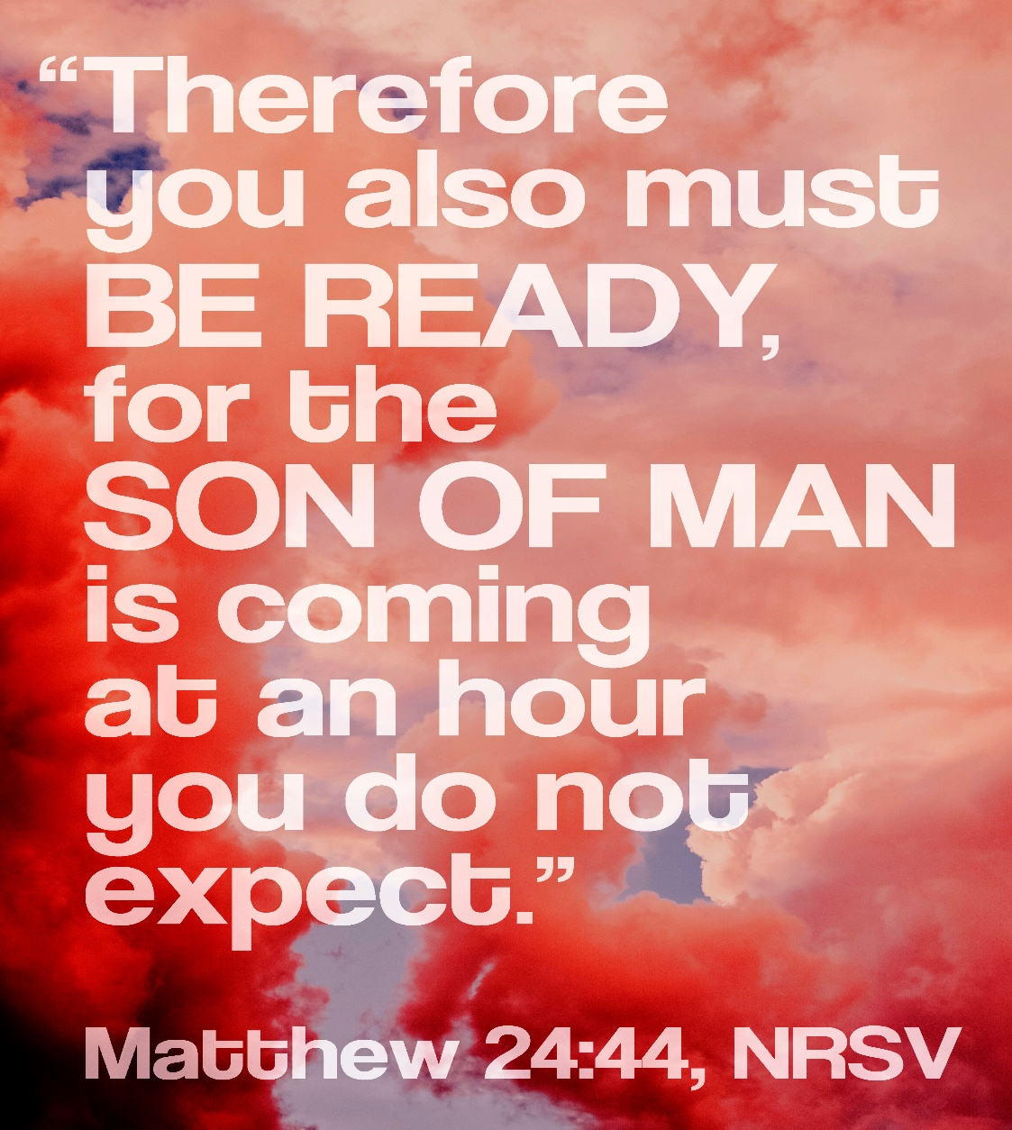

413 Geddes Avenue
Charleston, SC 29407

Phone: (843) 766-5239
Email: stmarkumcsec@gmail.com
Church Office Hours: Monday – Thursday
8:30 am – 1:30 pm
ANNOUNCEMENTS

WEEKLY CALENDAR

Sunday, November 30th
9:30 am Adult Sunday School
10:30 am Worship Service
10:45 am Children’s Sunday School
2:00 pm Cantata Rehearsal

Monday, December 1st
6:30 pm Yoga with Lisa Stine

Wednesday, December 3rd
6:00 pm Girls Scout Troop
6:00 pm Chancel Choir Rehearsal
7:30 pm Anita Carpenter Memorial Handbell Choir Rehearsal

BIRTHDAYS: Noelle Graham Motley (12/05), Sophie Anne Weiss (12/6), Katie Brown (12/7).

OUR PRESENCE…
Service Attendance Last Week: 73
Service Attendance Online Last Week: 11
Service Attendance Total: 84

OUR PRAYERS: Evan McMillan & Family; Andy Power – Healing and Salvation; Mrs. Carolyn Huckabees sister, Cheryl Hopkins – involved in a terrible car accident; Tiffany Rogers (Joy Maxey’s Daughter) – health concerns; Everette Beach and Dwan Beach (Geddings) – health concerns; The Dawson Family – prayers as they mourn the loss of their loved one, Claire Dawson; Latoya Fludd; Tyler Davis.

OUR GIFTS…

Needed Each Week for Budget: $4,285
Received Last Week for Budget:$7,918
Received Online for Budget:$405
Total Received for Budget:$8,323
YTD Receipts through October: $173,974
YTD Expenses through October: $189,152

TEXT GIVING -- to give via text, send SaintMarkUMC to 73256. You will receive a text message in response with your next steps. You may also scan the QR code to give online.

OUR SERVICE...

NURSERY VOLUNTEERS ACOLYTES
November 30th Betsy Petit November 30th Tristan Axman
December 7th Vicki Davidson December 7th Avery Seel
December 14th Rhonda Cummings December 14th Henry Seel
*We ask if you are a volunteer, please arrive 15 minutes early to prepare for your duties.*
BREAKFAST WITH SANTA, Next Saturday, December 6th at 9:00 am – 11:00 am.
It’s time again for our breakfast with Santa on the first Saturday of December, the 6th from 9:00 am t0 11:00 am. Food is provided and free for families. We hope you can join and there will be an opportunity to take photos with Santa. Should you have any questions, please reach out to Rhonda Cummings directly.

WOMEN’S CIRCLE, Next Sunday, December 7th at 7:00 pm.
Women’s Circle is rescheduled for next month on Sunday, December 7th at 7:00 pm, and will be held at the church in Heidtman Hall. Should you have any questions, please reach out to Patty Barfield or Rhonda Cummings directly.

GOOD NEIGHBORS, Wednesday, December 10th at 12:00 pm.
Good Neighbors is back and the date will be a week sooner than usual. We will have Good Neighbors on Wednesday, December 10th at 12:00 pm. As always, meat and drinks will be provided. If you are able, please bring a side dish to share. All are welcome, so invite family or friends if you feel they would like to join us! Should you have any questions, please reach out to Amelia Dawson directly.

CHRISTMAS CARRIAGE RIDE, Thursday, December 11th at 5:00 pm – 8:00 pm.
The Christmas Carriage Ride will be held on Thursday, December 11th at 5:00 pm – 8:00 pm. Due to limited seats in the carriage, they will likely stop adding to the ride list by 7:15 pm to prevent the rides from running over their allotted time. The earlier that you arrive the better. Should you have any questions, please contact Lisa Stine directly.

DEADLINE FOR POINSETTIA ORDERS, Sunday, December 14th.
Patty Barfield will be collecting orders beginning next week on Sunday, November 30th and will run orders through until Sunday, December 14th. The deadline for all orders is Sunday December 14th, so please provide your order slips as early as possible to UMW. Please make all checks payable to St. Mark UMW. If you have any questions, please contact Patty Barfield directly. Thank you.

CHRISTMAS CANTATA, Sunday, December 21st at 10:30 am.
The Christmas Cantata will be on the Sunday before Christmas in replacement of our regularly scheduled Sunday worship service at 10:30 am December 21st. An insert will be provided with further details as we move into December. Please note that all handbell and choir members will be taking photos during this event and following the Cantata for an update to the website for the coming year. If you have any questions, please reach out to Barbara Vena directly.

CHRISTMAS EVE CANDLELIGHT SERVICE, Wednesday, December 24th at 6:30 pm.
Christmas Eve Candlelight service will be held in the Sanctuary on Wednesday, December 24th at 6:30 pm. Should you have any questions, please reach out to the church office directly. Thank you.

BIRTHDAY PARTY FOR JESUS, Saturday, December 13th at 10 am & 20th at 9:00 am, plus Christmas Day, December 25th for deliveries.
Additional details will follow in the upcoming week as we move into December. MYF will have their first gathering to help wrap gifts on Saturday, December 20th at 10am. Should you have any questions or would like to volunteer to help, please reach out to Gail Lanter directly. Thank you.

