ST. MARK UNITED METHODIST CHURCH
Reverend Mike Bruce
Worship Service 10:30 am February 15, 2026

Transfiguration Sunday

PRELUDE “Crown Him with Many Crowns”
WORDS OF WELCOME

CENTERING WORDS

Glory fills the skies, as we see Christ transformed before our very eyes.

*CALL TO WORSHIP

L: Climb the mountain of God.
P: We will watch and wait.
L: Wait for God’s glory to shine like the sun.
P: Wait for Christ to reveal the heart of God.
L: Wait to gain courage for the terror of the night.
P: Wait for the Spirit to dispel the darkness.
L: Climb the mountain of God.
P: We will watch for things worth waiting for.

*OPENING PRAYER

Source of light and love, reveal to us your glory. As you appeared to your servant Moses in devouring fire on Mt. Sinai, appear to us now in power and might during our time of worship. As you revealed Christ’s resplendent light to his disciples on the mountaintop, reveal your radiant light to us during our fellowship together. Transform us with your glory, that our souls might shine your light into a world shrouded in darkness. In Jesus” name. Amen.

*HYMN OF PRAISE "Joyful, Joyful, We Adore Thee" UMH 89

*APOSTLES CREED UMH 881

*GLORIA PATRI UMH 70

CHILDREN’S MOMENT Rhonda Cummings

*PSALTER Psalm 99 UMH 819

JOYS AND CONCERNS

PASTORAL PRAYER

THE LORD’S PRAYER UMH 895

ANTHEM “Majesty Medley” Chancel Choir

TITHES & OFFERINGS

OFFERTORY “Spirit of God Descend Upon My Heart”
*DOXOLOGY UMH 95

*PRAYER OF DEDICATION

*HYMN OF PREPARATION “O Worship the King” UMH 73

SCRIPTURE LESSON Matthew 17: 1-9

SERMON LISTEN TO HIM! Rev. Mike Bruce

*HYMN OF RESPONSE “Immortal, Invisible, God Only Wise” UMH 103

*BENEDICTION
L: Climb the mountain of God.
P: We will walk in the light and truth of God.
L: Do not fear the voice that calls from the heavens.
P: We will heed our call to follow Jesus.
L: Draw near to God’s holy fire.
P: We will bathe in the warmth of our God.
L: Shine the light of Christ in the world.
P: We will be bold, for God goes with us.

*BENEDICTION RESPONSE “Threefold Amen” Chancel Choir

*POSTLUDE “O Love How Deep”

*Please stand (if able)

FLOWERS

FLOWERS were given by Renee Wilcox in Memory of Robert Wilcox!



FLOWER CALENDAR – The flower calendar is located on a display board directly to your right as
you enter the Narthex doors. Flowers may be placed for special occasions, in honor of, or in memory of loved ones. If you have questions regarding the placement of flowers, please contact the church office. As a reminder, flowers are at a cost of $43.60 per vase. There are typically two vases, and you may choose to share a Sunday with someone else.
CHURCH STAFF

Rev. Mike Bruce – Pastor
Email: revmbruce@gmail.com
Phone: (843) 206-5283

Barbara Vena – Music Director
Email: bavena@gmail.com
Phone: (609) 709-6027

Chuck Long – Organist
Email: clongteach@comcast.net
Phone: (843) 693-6664

Jamie Ackerman – Church Admin
Email: stmarkumcsec@gmail.com
Phone: (843) 766-5239

Stacey Shealy – St. Mark Day School Director
Email: staceyshealy@gmail.com
Phone: (843) 343-4457

2026 LEADERSHIP POSITIONS

Betsy Petit – Church Council Chairperson
Mark Seel – Trustee Chairperson
Kenny Barfield – Trustee Vice-Chairperson
Vicki Davidson – SPPRC Chairperson
Dawn Ackerman – Finance Chairperson
Elaine Gooch – Church Treasurer

(A complete listing of 2026 Leadership Positions is available on the table in the Narthex)
ST. MARK UNITED METHODIST CHURCH

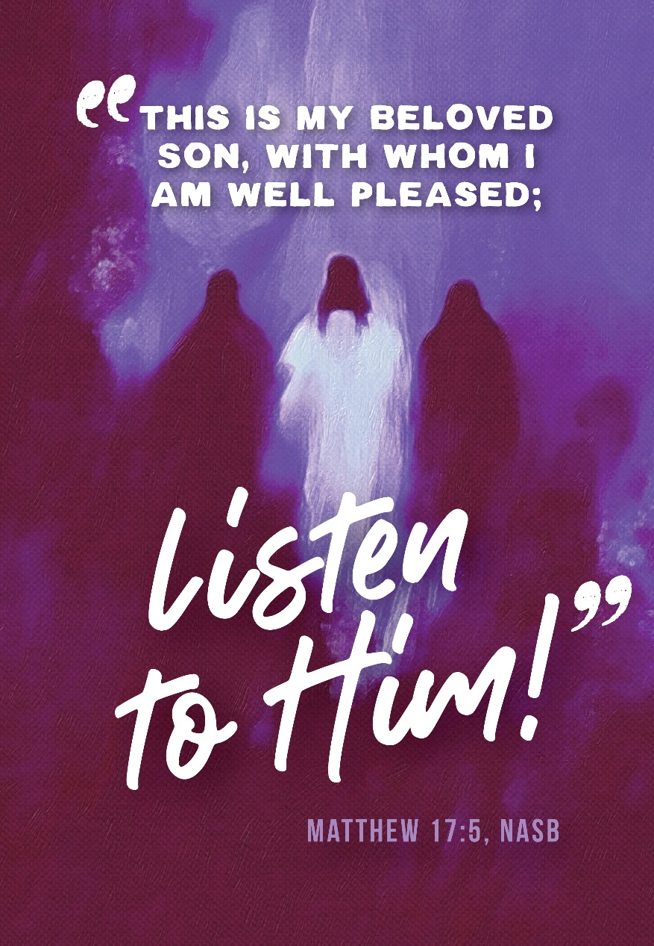
413 Geddes Avenue
Charleston, SC 29407

Phone: (843) 766-5239
Email: stmarkumcsec@gmail.com
Church Office Hours: Monday – Wednesday: 8:00 am – 1:00 pm
Thursday: 7:00 am – 12:00 pm
Friday: 1:00 pm - 7:00 pm (Janitorial Cleaning)
ANNOUNCEMENTS
BIRTHDAY, ADDRESS, PHONE NUMBER, EMAIL UPDATES!
If you are unsure or have experienced that your birthday has been missed, mail is not being delivered to your current address, or your contact information has changed and you want to ensure that it is updated with the church office records, please reach out to Linda Shealy to ensure that she has the current information. She can be emailed at lhshealy@gmail.com.

WEEKLY CALENDAR

Sunday, February 15th
9:30 am Adult Sunday School
10:00 am Choir Rehearsal
10:30 am Worship Service
10:45 am Children’s Sunday School
5:00 pm MYF

Monday, February 16th
All Day Office Closed (Presidents Day)
6:30 pm Yoga with Lisa Stine

Wednesday, February 18th
12:00 pm Good Neighbors Luncheon
6:00 pm Chancel Choir Rehearsal
7:30 pm Anita Carpenter Memorial Handbell Choir Rehearsal

BIRTHDAYS: Sadie Louise Weiss (2/18), Ron Buchheit (2/22).
*Previous Week Missed: Eli Davis Motley (2/9), Sally Duncan (2/12).

OUR PRESENCE…
Service Attendance Last Week: 71
Service Attendance Online Last Week: 14
Service Attendance Total: 85

OUR PRAYERS: Evan McMillan & Family, Catherine Burbank.

OUR GIFTS…

Needed Each Week for Budget: $4,285
Received Last Week for Budget: $25,454
Received Online for Budget: $515
Total Received for Budget: $25,969
YTD Receipts through January: $16,188
YTD Expenses through January: $16,614

TEXT GIVING -- to give via text, send SaintMarkUMC to 73256. You will receive a text message in response with your next steps. You may also scan the QR code to give online.

OUR SERVICE...

NURSERY VOLUNTEERS ACOLYTES
February 15th Unknown February 15th Tristan Axman February 22nd Unknown February 22nd Henry Seel
March 1st Unknown March 1st Tristan Axman

*We ask if you are a volunteer, please arrive 15 minutes early to prepare for your duties.*

GOOD NEIGHBORS, Wednesday, February 18th at 12:00 pm.
Our monthly Good Neighbors luncheon will be this Wednesday, February 18th at 12:00 pm. Everyone is welcome so please invite your family and friends. It is such a wonderful time for fellowship. If you are able, please bring a side dish to share. Meat and drinks will be provided. Should you have any questions, please reach out to Amelia Dawson directly.

CHURCH OFFICE HOURS HAVE CHANGED!
Please note that our church office hours are changing for the upcoming year effective immediately. We want to ensure that we are supporting all the needs of the church, as well as our staff’s personal scheduling. If there are any questions or concerns, please contact the St. Mark UMC church office. The new schedule will be as follows:
Church Office Hours:
Monday – Wednesday: 8:00 am – 1:00 pm
Thursday: 7:00 am – 12:00 pm
Friday: 1:00 pm - 7:00 pm (Janitorial Cleaning)

Pastor Office Hours:
By Appointment Only

UNITED METHODIST MEN’S RETREAT, COLUMBIA, SC ON FEBRUARY 21st at 8:00am.
There is United Methodist Men’s Retreat in Columbia, SC on February 21st from 8am-3pm. David Axman would like to extend an invitation for anyone at St. Mark who would like to carpool around 6am that morning and come back that night. The conference is $65, but they have other activities the day before that can be signed up for separately, such as a golf tournament and Cigars & Scriptures. Anyone interested please sign up using the link https://www.umcsc.org/mennministryretreatreg/ and contact David Axman directly if you would like to carpool.
Church Office Closed, Monday 16th, 2026
The church office will be closed tomorrow, Monday 16th, for Presidents Day. Should you have any questions or concerns, please do not hesitate to reach out via email. All responses will be received within 24 hours.
Thank you,
St Mark UMC Office
Dear St. Mark,

As I write this, it is February 11th. All I can say is that time really flies, doesn’t it? I must confess that I have allowed something to slip up on me. One week from today is Ash Wednesday.
Many churches hold an Ash Wednesday service. Normally we do. The one thing I have always believed is that the ashes should be worn as a witness to our faith. Yet, when we hold Ash Wednesday service in the evening, this usually does not happen. We have ashes imposed, go home after the service, and wash them off.
So, I am writing to you to let you know that this year we will not be holding a traditional Ash Wednesday service this year. Instead, we are going to allow you to be the service by wearing your ashes during the day as your witness. Twice during the day, from 7:00 am until 8:30 am and from 11:00 am until 12:00 pm. We will be available to impose ashes upon your forehead. The first time will be in our parking lot. You will not even have to leave your car. During the second one we will have ashes imposed either in your car or in the Sanctuary in case you wish to kneel at the altar and pray.
Make plans to come and receive the ashes, so that you may wear them as a witness throughout your day.

Pastor Mike
Dear St. Mark,

As I write this, it is February 11th. All I can say is that time really flies, doesn’t it? I must confess that I have allowed something to slip up on me. One week from today is Ash Wednesday.
Many churches hold an Ash Wednesday service. Normally we do. The one thing I have always believed is that the ashes should be worn as a witness to our faith. Yet, when we hold Ash Wednesday service in the evening, this usually does not happen. We have ashes imposed, go home after the service, and wash them off.
So, I am writing to you to let you know that this year we will not be holding a traditional Ash Wednesday service this year. Instead, we are going to allow you to be the service by wearing your ashes during the day as your witness. Twice during the day, from 7:00 am until 8:30 am and from 11:00 am until 12:00 pm. We will be available to impose ashes upon your forehead. The first time will be in our parking lot. You will not even have to leave your car. During the second one we will have ashes imposed either in your car or in the Sanctuary in case you wish to kneel at the altar and pray.
Make plans to come and receive the ashes, so that you may wear them as a witness throughout your day.

Pastor Mike

