**ST. MARK UNITED METHODIST CHURCH**

Reverend: Mike Bruce

Worship Service 10:30 am August 11, 2024

***12th Sunday after Pentecost***

**PRELUDE** “Redeemed” *arr. William Barnett* *Timothy Moore*

**WORDS OF WELCOME**

**\*CALL TO WORSHIP**

L: We have gathered from different places and different backgrounds.

**P: May those who are grieving find comfort.**

L: May those who have turned away from God find forgiveness.

**P: May those who are waiting find hope.**

L: May all find God’s steadfast love and grace.

**P: Let us worship the One who gives us life!**

**\*OPENING PRAYER** (Unison)

Jesus, Bread of Life, you give us life and nourish our spirits. As your beloved children, help us to walk in your ways, each and every day. May we speak words of kindness to one another and open our hearts to share comfort and encouragement. May we offer and seek forgiveness. Most of all, may we remember that your steadfast love extends to all of your beloved children. We pray in your holy name. Amen.

**\*HYMN OF PRAISE** “Lord, I Want to Be a Christian” **UMH 402**

**\*APOSTLE’S CREED UMH 881**

**\*GLORIA PATRI UMH 70**

**PSALTER** Psalm 130 **UMH 848**

**JOYS AND CONCERNS**

**PASTORAL PRAYER**

**THE LORD’S PRAYER UMH 895**

**ANTHEM** “God Leads Us Along” *arr. George A Young* *Chancel Choir*

**TITHES & OFFERINGS**

**OFFERTORY** *Timothy Moore*

**\*DOXOLOGY UMH 95**

**\*PRAYER OF DEDICATION**

**\*HYMN OF PREPARATION** “Precious Lord, Take My Hand” **UMH 474**

**SCRIPTURE LESSON John 6: 35, 41-51**

**SERMON** THE SHELF WILL NEVER BE EMPTY *Rev. Mike Bruce*

**\*HYMN OF RESPONSE** “God Be with You till We Meet Again” **UMH 673**

**\*BENEDICTION**

**\*BENEDICTION RESPONSE** Threefold Amen *Timothy Moore*

**\*POSTLUDE** “This is My Father’s World” *arr. Stan Pethel* *Timothy Moore*

*Please stand (if able)*

**ANNOUNCEMENTS**

FLOWERS are given to the Glory of God!

**

*FLOWER CALENDAR – The flower calendar is located on a display board directly to your right as  
you enter the Narthex doors. Flowers may be placed for special occasions, in honor of, or in memory of loved ones. If you have questions regarding the placement of flowers, please contact the church office. As a reminder, flowers are at a cost of $43.60 per vase. There are typically two vases, and you may choose to share a Sunday with someone else.*

**CHURCH STAFF**

**Rev. Mike Bruce –** Pastor

**Email:** [revmbruce@gmail.com](mailto:revmbruce@gmail.com)

**Phone:** (843) 206-5283

**Jamie Ackerman** – Church Admin

**Email:** [stmarkumcsec@gmail.com](mailto:stmarkumcsec@gmail.com)

**Phone:** (843) 766-5239

**Timothy Moore –** Music Arts Director

**Email:** [timmmoore101@gmail.com](mailto:timmmoore101@gmail.com)

**Phone:** (843) 751-5121

**Stacey Shealy –** St. Mark Day School Director

**Email:** [staceyshealy@gmail.com](mailto:staceyshealy@gmail.com)

**Phone:** (843) 343-4457

**2024 LEADERSHIP POSITIONS**

**Betsy Petit** – Church Council Chairperson

**Mark Seel** – Trustee Chairperson

**Kenny Barfield** – Trustee Vice-Chairperson

**Vicki Davidson** – PPRC Chairperson

**Dawn Ackerman** – Finance Chairperson

**Elaine Gooch** – Church Treasurer

*(A complete listing of 2024 Leadership Positions is available on the table in the Narthex)*

**ST. MARK UNITED METHODIST CHURCH**

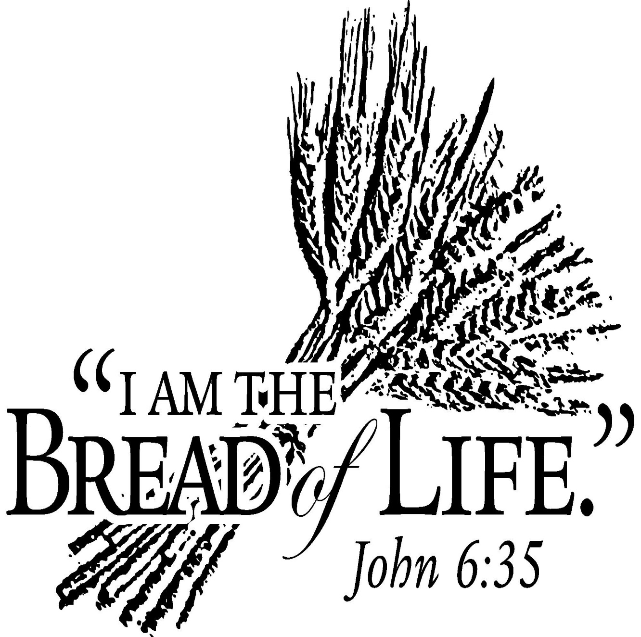

413 Geddes Avenue

Charleston, SC 29407

**Phone:** (843) 766-5239

**Email:** [stmarkumcsec@gmail.com](mailto:stmarkumcsec@gmail.com)

**Church Office Hours:** Mon, Wed: 9 am – 5 pm

Fri: 9 am – 12 pm

**ANNOUNCEMENTS cont’d**

**WEEKLY CALENDAR**

**Sunday, August 11th**

9:30 am Adult Sunday School

9:45 am Children’s Sunday School

10:00 am Chancel Choir Practice

10:30 am Worship Service

**Monday, August 12th**

7:00 pm Council Meeting

**Wednesday, August 14th**

6:00 pm Chancel Choir Rehearsal

**BIRTHDAYS:** Peggy McMillan Elsey (8/14), Stephanie Peralta Davis (8/14), Michael Barfield (8/15), Johnny Matthew Seel (8/15), Carl Seel (8/17), Steve Lee (8/17), Ryan Scott Donahoo (8/17).

**OUR PRESENCE…**

Service Attendance Last Week: 53

Service Attendance Online Last Week: 7

Service Attendance Total: 60

**OUR PRAYERS:** Susan Brooks, Denise Chan, Linda Curry, Libby Massalon, Bennett McMillan, Evan McMillan & Family, Harold McMillan, Michele Shaw, Eloise Wooden, Tracy Power – healing, Willy Puckharber – healing and salvation, Lisa Stine and Family, Rhonda Cummings and Family, Chris O’Toole (Brett and Abby’s mother) – surgery and recovery, Darlene Persons (Sally Duncan’s daughter) – healing and prayers, Bobby Young – recovering from recent surgery, Irene Stevens (Catherine Burbank’s Mom) – healing and recovery, Susie Seel – healing and recovery from surgery.

*(If you have any additions, deletions or corrections to the Prayer List, please notify the church office by no later than Wednesday.)*

**Church Council Meeting (Rescheduled)**

The church council meeting was **rescheduled for August 12th at 7:00pm.** If you should have any questions, please reach out to the church office for assistance.

Thank you.

**OUR GIFTS…**

Needed Each Week for Budget: $5,000

Received Last Week for Budget: $5,371

Received Online for Budget: $910

Total Received for Budget: $6,281

YTD Receipts: $104,321

YTD Expenses: $107,775

**TEXT GIVING** -- to give via text, send SaintMarkUMC to 73256. You will receive a text message in response with your next steps. You may also scan the QR code to give online.

**OUR SERVICE...**

**NURSERY VOLUNTEERS**

August 11 Cindy Dix

**FOOD PANTRY**

The food pantry is running low on items. Items needed are peanut butter, jelly, canned meats, individual cereals, canned spaghetti, soups, canned green beans, peas, corn, canned fruits.