ST. MARK UNITED METHODIST CHURCH
Reverend Mike Bruce
Worship Service 10:30 am August 2, 2026

10th Sunday after Pentecost
Communion Sunday

PRELUDE “When Morning Guilds the Skies”

WORDS OF WELCOME

CENTERING WORDS
God’s love and grace welcome us here. Christ’s bounty feeds us at his table.

*CALL TO WORSHIP

L: My people are hungry.
P: There are too many to feed.
L: Give them something to eat.
P: We have only five loaves and two fish.
L: You have everything you need.
P: It would take a miracle.
L: With God all things are possible.
P: In Christ, new hope has dawned.

*OPENING PRAYER
Even when our faith falters, O Lord, we will not let you go. Even though we are
battered and bruised, O God, we will not let you go. Even when our bellies are empty, we
know your presence will satisfy us. We need your blessing, O God, and we will not let you go.
In Jesus’ name. Amen.

*HYMN OF PRAISE “Precious Lord, Take My Hand” UMH 474

*THE APOSTLES CREED UMH 881

*GLORIA PATRI UMH 70

CHILDREN’S SERMON Rhonda Cummings

*PSALTER Psalm 17: 1-7, 15 UMH 749

JOYS AND CONCERNS

PASTORAL PRAYER

THE LORD’S PRAYER UMH 895

ANTHEM “Let Us Be Bread” by Porter

TITHES & OFFERINGS

OFFERTORY “Father Teach Us How to Pray” Solo McKenzie Nichols by Florence Jolley
*DOXOLOGY UMH 95

*PRAYER OF DEDICATION

*HYMN OF PREPARATION “Let Us Break Bread Together” UMH 618

SCRIPTURE LESSON Matthew 14: 13-21

SERMON THE GLASS IS HALF FULL Rev. Mike Bruce

HOLY COMMUNION UMH 13

*HYMN OF RESPONSE “When Jesus the Healer Passed Through Galilee” UMH 263

*BENEDICTION

L: Go with the One who brings us through the wilderness into a land flowing with milk
and honey.
P: We go with the blessings of God, who greets us face to face.
L: Go with the One who heals our wounds and makes us whole.
P: We go with the blessings of God, who bathes us in the power of the Holy Spirit.

*BENEDICTION RESPONSE “Threefold Amen”

*POSTLUDE “God Be with You Until We Meet Again”
*Please stand (if able)
FLOWERS

FLOWERS were given by Mark and Susie Seel to the Glory of God!



FLOWER CALENDAR – The flower calendar is located on a display board directly to your right as
you enter the Narthex doors. Flowers may be placed for special occasions, in honor of, or in memory of loved ones. If you have questions regarding the placement of flowers, please contact the church office. As a reminder, flowers are at a cost of $43.60 per vase. There are typically two vases, and you may choose to share a Sunday with someone else.
STAFF

Rev. Mike Bruce – Pastor
Email: revmbruce@gmail.com
Phone: (843) 206-5283

Barbara Vena – Music Director
Email: bavena@gmail.com
Phone: (609) 709-6027

Chuck Long – Organist
Email: clongteach@comcast.net
Phone: (843) 693-6664

Jamie Ackerman – Church Admin & Financial Secretary
Email: stmarkumcsec@gmail.com
Phone: (843) 766-5239

Stacey Shealy – St. Mark Day School Director
Email: staceyshealy@gmail.com
Phone: (843) 343-4457

2026 LEADERSHIP POSITIONS

Betsy Petit – Church Council Chairperson
Mark Seel – Trustee Chairperson
Kenny Barfield – Trustee Vice-Chairperson
Vicki Davidson – SPPRC Chairperson
Dawn Ackerman – Finance Chairperson
Elaine Gooch – Church Treasurer

(A complete listing of 2026 Leadership Positions is available on the table in the Narthex)
ST. MARK UNITED METHODIST CHURCH

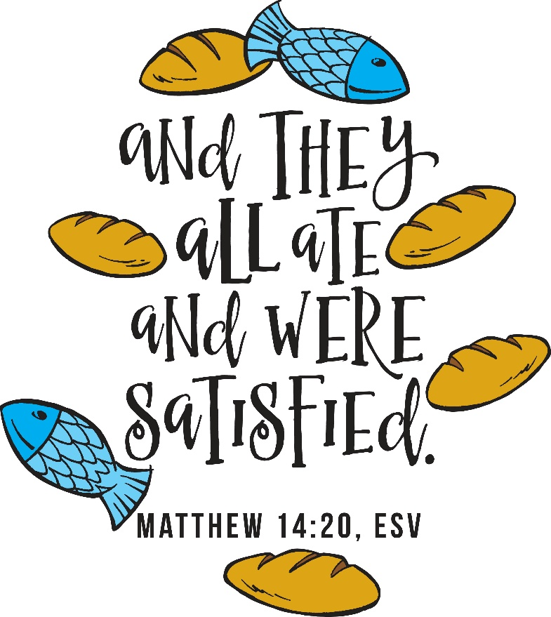

413 Geddes Avenue
Charleston, SC 29407

Phone: (843) 766-5239
Email: stmarkumcsec@gmail.com
Church Office Hours: Monday – Thursday: 8:00 am – 1:00 pm

ANNOUNCEMENTS

WEEKLY CALENDAR

Sunday, August 2nd
9:30 am Adult Sunday School
9:45 am Choir Rehearsal
10:30 am Worship Service
10:45 am Children’s Sunday School

Monday, August 3rd
6:30 pm Church Council Meeting
6:30 pm Scripture Yoga with Lisa Stine

Wednesday, August 5th
9:30 am Bridge Club
6:00 pm Chancel Choir Rehearsal

BIRTHDAYS: Kitty Duncan (8/3), Eleanor Rachel Motley (8/3), Haley McKenzie Smith (8/4), Charlotte Kate Albright (8/5), Barbara Chandler (8/7).

OUR PRESENCE…

Service Attendance Last Week: 68
Service Attendance Online Last Week: 11
Service Attendance Total: 79

OUR PRAYERS: Allen Scarborough – cancer, George Hernandez – cancer, Jimmy Henderson.

OUR GIFTS…
Needed Each Week for Budget: $4,285

Received Last Week for Budget: $1,169
Received Online for Budget: $530
Total Received for Budget: $1,699
YTD Receipts through June: $143,971
YTD Expenses through June: $104,166

TEXT GIVING -- to give via text, send SaintMarkUMC to 73256. You will receive a text message in response with your next steps. You may also scan the QR code to give online via text.

OUR SERVICE

HIGHER EDUCATION; College Student Updates
Should you have a student that will be attending college this year, please notify the church office of the following details: Student name, year attending, school address, and contact phone number. We would like to ensure we have everyone on our list, including all new college students attending. Thank you!

CHURCH COUNCIL, Monday, August 3rd at 6:30pm.
Church Council will be meeting tomorrow night in the conference room at 6:30pm. Please ensure that you have reviewed all documents that were emailed previously. This meeting will be for coordinating the end of year events, and planning for the beginning of 2027. Thank you.

BLESSING OF THE BACKPACKS, Next Sunday, August 9th.
There will be a blessing of backpacks for kids going back to school. If you would like to have your children bring their backpacks, you may do so on this date. They will be blessed immediately following the worship service. Light refreshments will be served. May we all pray for each child and teacher as they grow closer to beginning the school year once again.

CHARELSTON WESLEY FOUNDATION VISIT by Director John Poole, Sunday, August 9th.
Director John Poole of the Charleston Wesley Foundation will be visiting St. Mark UMC on Sunday, August 9th, during our worship service. He will share a little bit about what CWF foundation is and what it does for Charleston’s amazing group of young college students. He will also be mentioning the Foundation Dinner that is scheduled for October 17th. Seats are $40 per person, and there will be an exciting silent auction as well. All funds raised during this event are solely for the purpose of outreach to college students with the goal of creating more disciples of Jesus Christ. More details will be included as we move closer to the date. Jamie will attend the Foundation Dinner and would love to have a group from St. Mark UMC attend together in support of CWF’s ministry.

PARENTS NIGHT OUT, Registration is still available for our final date!

August 14th 5:00pm – 8:00pm (Only 3 spots left)

We are down to the final date for the summer with only three available slots left, so there is no time to waste. Get registered now! This event has proven to be such an amazing fundraiser and outreach opportunity for our church and children’s ministry. We can’t wait to see everyone for our final night out! Should you have any questions, please contact Rhonda Cummings or Jamie Ackerman directly. Thank you!

